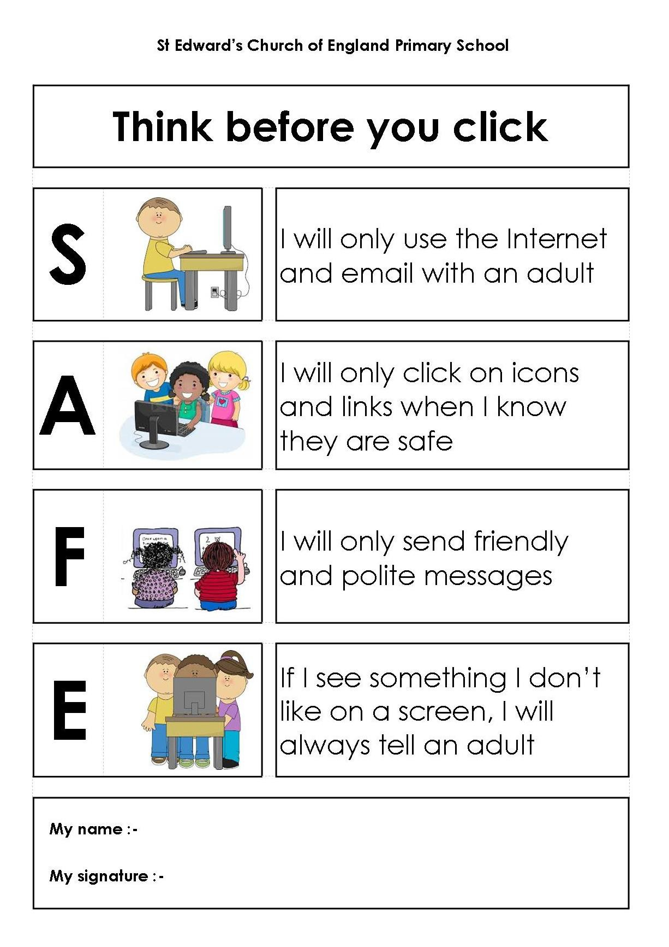

**Name of Child: ____________________________**

**Class: ____________________________**

**Parent Signature: ____________________________**

**Date: ____________________________**

**If I see something online that I don’t like, upsets or worries me I will tell an adult I trust.**

**I will be polite and friendly when online.**

**I will only click on apps, icons and links that I know are safe. If I’m not sure I will ask an adult first.**

**I will only use technology, apps and the internet with the permission of an adult.**

# Pupil Acceptable Use Policy Agreement (KS1)