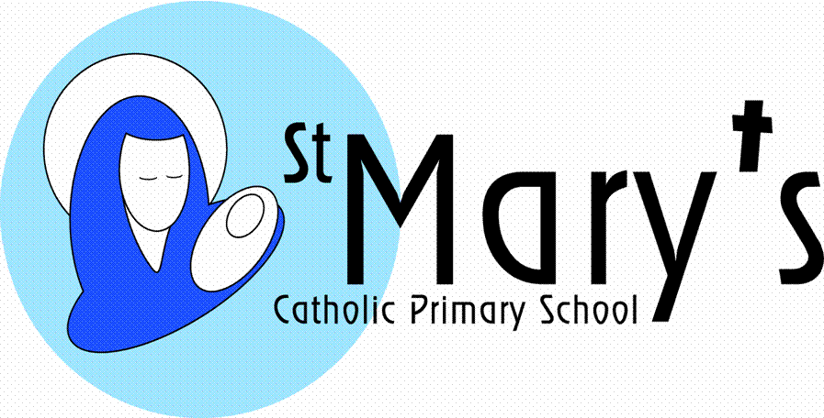
Year 3
Summer Term 1st half

Theme Parks
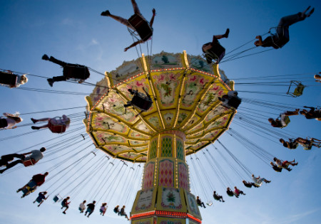

It’s excitement all the way with this high flying topic. Science will feature highly as the children discover all of the forces and friction involved in theme park mechanisms. They will be designing their own theme park, using mapping skills to map it out and comparing it to other theme parks around the world. A visit to Flambards will help with ideas. They will consider tourism and transport links when they evaluate the best places to build theme parks. These settings will provide the inspiration for persuasive writing and also adventure and mystery stories. I CT will be used to create advertising posters and also to enhance the art work which will focus on pop art style expressions. The history of theme parks will also be studied with a focus on fair ground rides and attractions in Victorian times.
  Literacy | The children will create their own adventure and mystery stories relating to the rides in the theme park. They will use persuasive writing techniques to produce advertising brochures for theme parks. Finally they will make a shape poem related to a theme park ride.
Maths | Every term the children will cover a variety of maths objectives related to five main areas:  Counting, partitioning and calculating  Securing number facts and understanding shape  Handling data and measures  Calculating and measuring  Reasoning and applying mathematical ideas.
Science | Forces, friction and magnetism are the main focus of the science. The children will use first hand experience and observational skills to look at the forces involved in theme park rides. They will then attempt to recreate these forces for themselves. They will carry out friction experiments to discover the best surfaces and materials for sliding and stopping; depending on the type of ride they are considering. In addition the children will look at the impact of developments like theme parks on local habitats.
History | Carousels, Penny Machines, Clapping Monkeys… the children will explore the things that excited Victorian children at the fun fair and compare and contrast them with amusements of today. In doing so they will discover a little of what life was like to be a child in Victorian Britain, taking into account the different experiences of the rich and poor.
  Geography | The children will look at the potential impact of tourism and the infra structure required for tourists when a plan for a theme park is considered. They will use atlases and maps to locate world theme parks and will study small scale site maps. They will use these ideas to create maps and plans for their own theme park design. Points of the compass will be important in giving directions around their sites.
Art | The art for this topic has a drawing focus; looking carefully at facial proportion. The children will explore the different emotions of the theme park and draw how these are expressed on faces. They will digitally photograph different expressions and use ICT pop art to create Andy Warhol style images.
DT | This is purely a design project where the children will be given the task of designing a layout for a modern day theme park. They will create a poster to advertise it, draw plans of the rides and a map of the park layout. In doing this they will have to consider the geographical location and available facilities.
ICT | .In this topic the children will use ICT to communicate – advertising their theme parks and making questionnaires for land use. They will also use it in art for recreating pop art images of facial expressions, linked to hair raising rides!. Children use Flowol to control a fairground ride (Big Wheel). Whilst on their trip they will consider the vast use of IT in modern day theme parks.  Throughout the topic digital literacy (e-safety) skills will be developed.
  Music | The children will explore sound effects for this topic, in particular creating sound effects for specific theme park rides like the ghost train.
PSHE | This falls into two categories. Firstly staying safe at a theme park and behaving sensibly in situations where peer pressure can be an influencing factor. Secondly a hypothetical dilemma about the situation of a theme park and considering the effects, both positive and negative, that it will have on the local community.
Homework | Children are expected to read at home daily. This could be any reading material so long as the children are experiencing a wide range of genre. Homework will be given twice a week. The first piece will be set on a Tuesday, to be handed in by Thursday and the second set on Friday to be completed by Tuesday.
Economic Wellbeing and Financial Capability | This is a design project where the children will be given the task of designing a layout for a modern day theme park. They will create a poster to advertise it, draw plans of the rides and a map of the park layout. They will get a simplified idea about costings and running costs as they plan to advertise their theme parks. The children will look at the potential impact of tourism and the infra structure required for tourists when a plan for a theme park is considered. They will discuss the hypothetical dilemma about the situation of a theme park and considering the effects, both positive and negative, that it will have on the local community. They will interview local groups to determine the impact of tourism on the lives of all potentially affected.
  British Values | Teamwork is the core of this topic. The children will develop mutual respect of each other and their opinions as they learn to make choices. They will develop their self-knowledge, self-esteem and self-confidence as they explore the language of fear and anxiety.  Mutual respect and tolerance of other faiths and beliefs are taught in our RE topics.
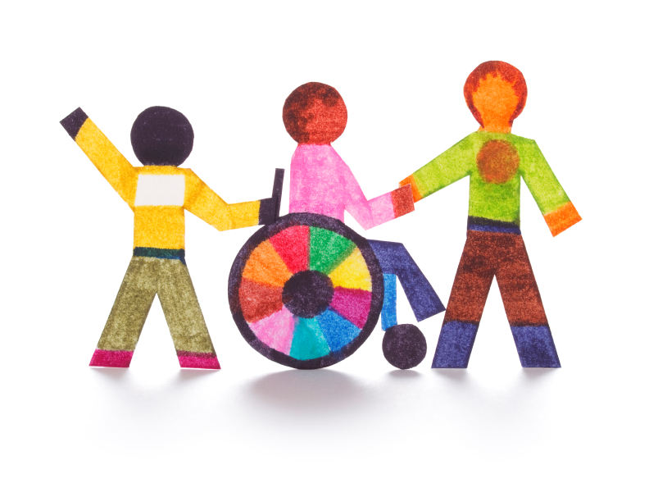  Safeguarding | This will be a major feature of this topic. Theme parks are notoriously busy places, full of strangers and other dangers. The messages of stranger danger will be reinforced. The children will also discuss the importance of agreed meeting points and identify who is safe to ask if they get lost in a crowded place. In addition they will discuss the safety of rides and how to minimize risks. They will look into why rides may have height or age restrictions and begin to understand the importance of adhering to them.
Pupil Premium    Cultural Capital | Children will:  - Visit a theme park (Flambards)

